Tasks:
In this exercise, you are required to build, train, and evaluate a Convolutional Neural Network (CNN) for image classification using the Fashion-MNIST dataset. You will load and preprocess image data, design a multi-layer CNN architecture using TensorFlow/Keras, and train the model to recognize different object categories. After training, you will evaluate the model's performance on unseen test data and visualize the training loss across epochs. The objective of this exercise is to provide hands-on experience with Deep Learning and Computer Vision, enabling you to understand the complete end-to-end workflow of an image classification project. You must use TensorFlow/Keras only. PyTorch is not allowed. You can use any programming environment such as Jupyter Notebook, Google Colab, VS Code, or any other Python editor to write and execute your code. After completing each task, take screenshots of your code and its output, and paste them into a single MS Word (.doc/.docx) file for submission.

1. Data Loading and Preprocessing: (Marks 2) • Load the Fashion-MNIST dataset from keras datasets
• Load the training and test images along with their labels
• Normalize the pixel values to the range [0, 1]
• Reshape the images appropriately for input to a CNN (e.g., (28, 28, 1) for grayscale images)
• Provide a few sample images with their corresponding labels.

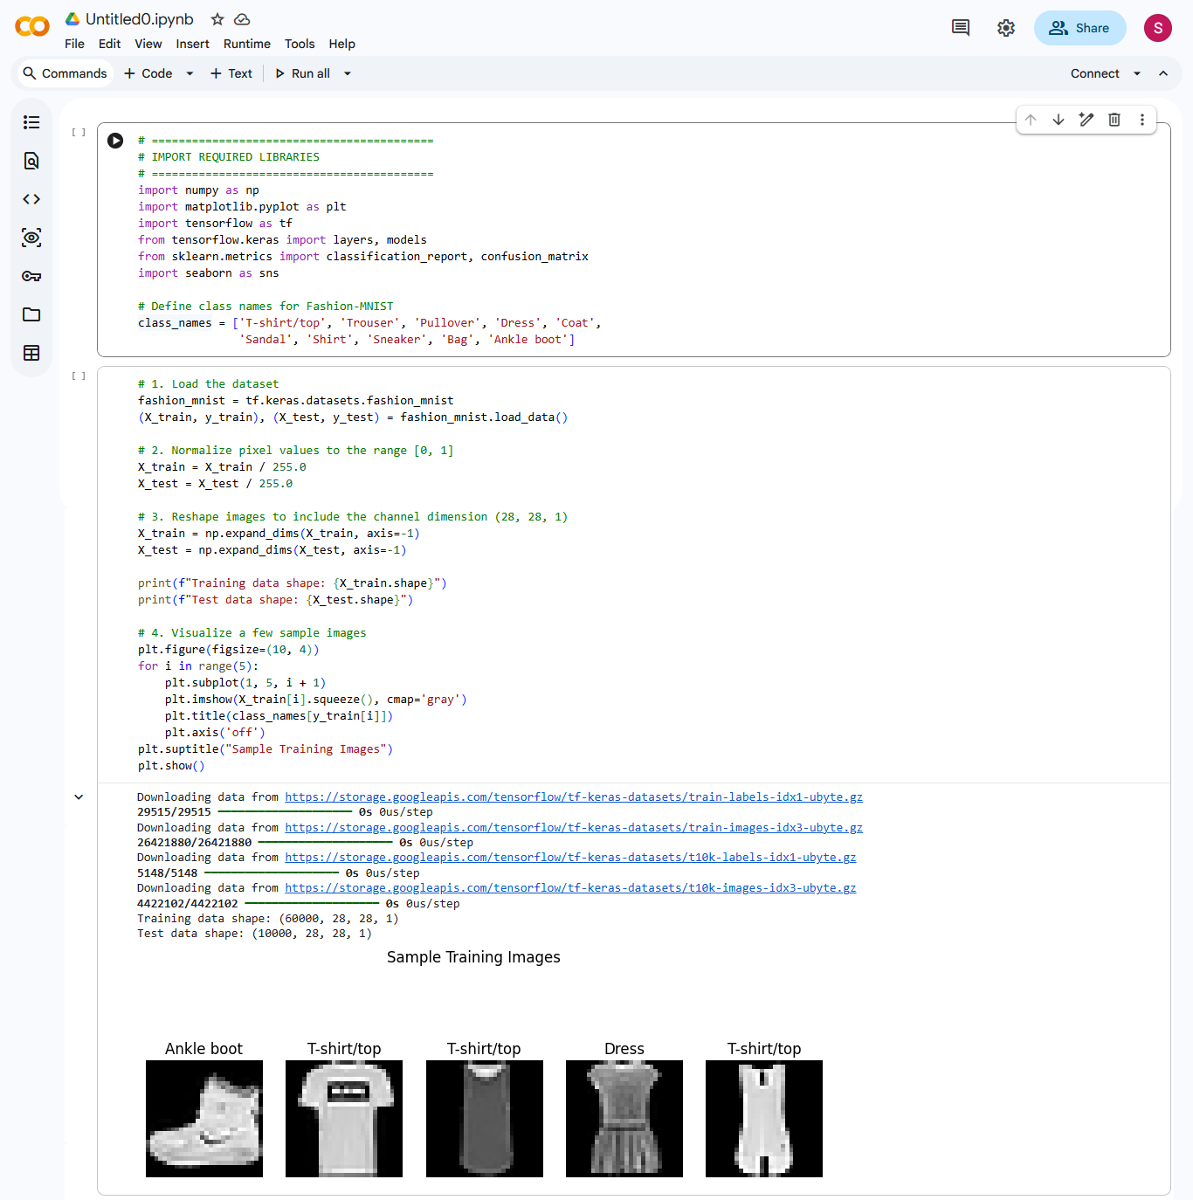

2. Design / Build the CNN Model: (Marks 2)
• Design a multi-layer Convolutional Neural Network using TensorFlow/Keras
• Include at least:
o 2 convolutional layers
o MaxPooling layers
o Dropout for regularization
o Flatten layer before the dense layers
o Dense layers leading to the output layer
• Compile the model using an appropriate optimizer, loss function, and evaluation metric for classification

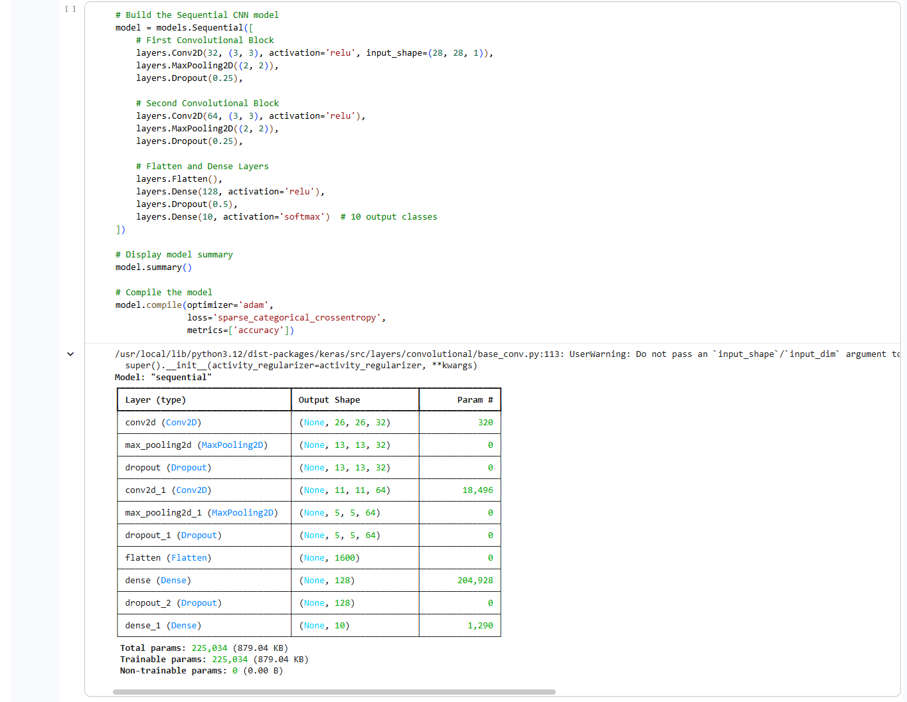

3. Compile and Train your Model: (Marks 2) • Train the CNN using the training dataset
• Use a validation split (e.g., 10–20%) to monitor the model performance during training
• Train the model for a sufficient number of epochs to achieve stable accuracy
• Display the training and validation accuracy/loss per epoch

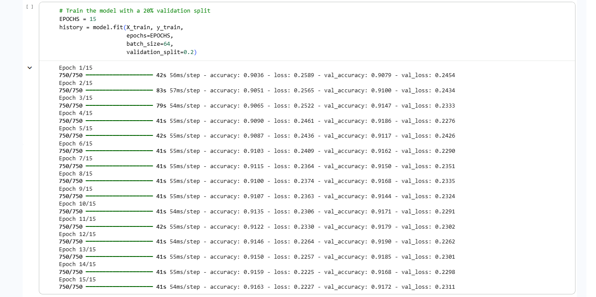

4. Model Evaluation: (Marks 2) • Evaluate the trained model on the unseen test dataset
• Report the test accuracy and loss
• Generate a confusion matrix and classification report showing performance on different fashion categories

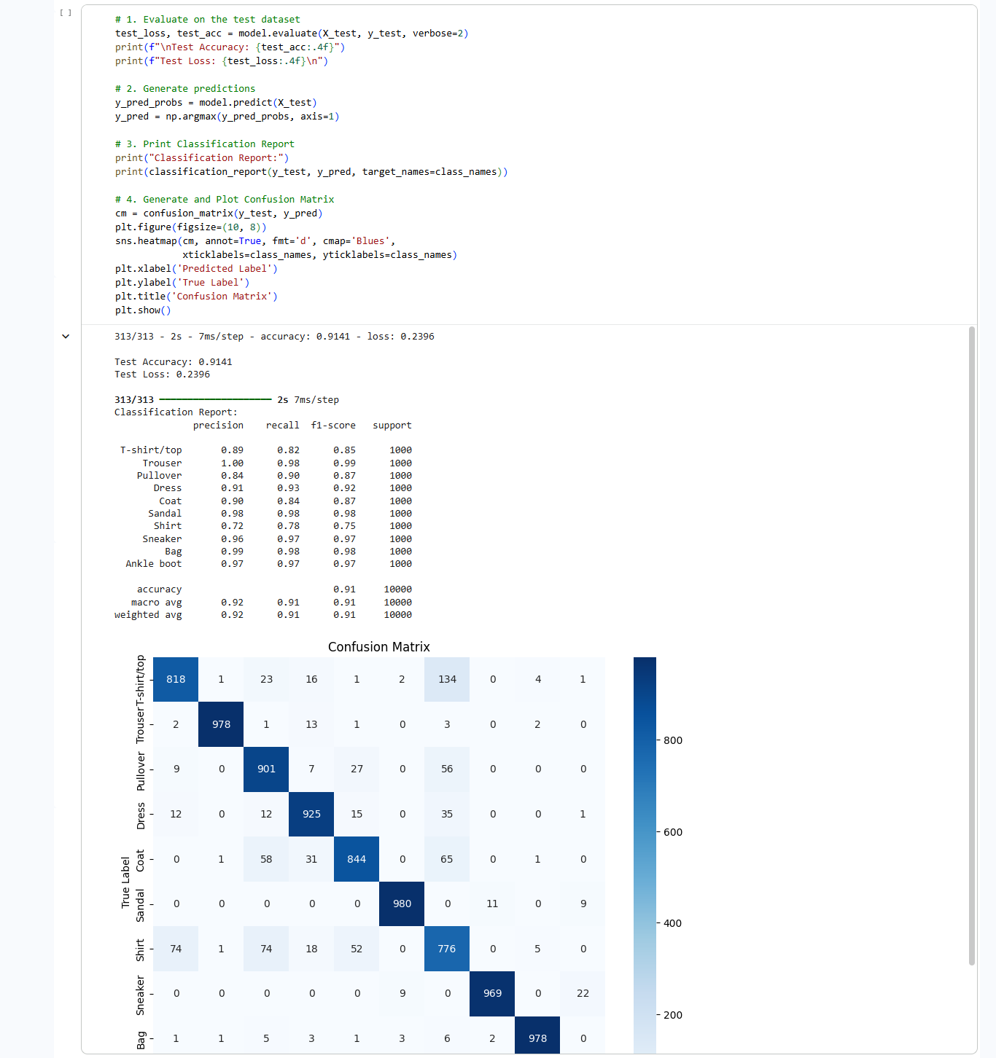

5. Visualization and Analysis of the results: (Marks 2) • Plot the training loss and accuracy curves across epochs
• Plot a few test images along with the predicted and true labels

